# Data files

|  |  |  |  |  |
| --- | --- | --- | --- | --- |
| **File name** | **Description** | **Structure** | **Admin.py** | **Hangman.py** |
| **word_list.json** | List of words used for hangman | dict | Read, write | Read |
| **game_settings.json** | Stores game settings and value | dict | Read, write | Read |
| **game_log.json** | Records of games played | Dicts nested in list | Read | Read, write |
| **passwd.json** | Stores admin password | str | Read, write | N/A |
| **hang.json** | Stores ascii art for different hangman stages | list | N/A | Read |

# Running admin script

To run the script, locate the admin.py script and press “play” at the top right of the screen to run the script in python 3.11.0

Figure Play button to run script

When running the script, you will be prompted to enter your username and password. Enter ‘admin’ for username and the default password is ‘qQ1@’ (this can be changed in the script). After 3 failed login attempts, the script will end itself.



Figure Example of successful login

Upon successful login, you will be able to see the menu to admin options

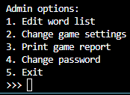

Figure Admin options menu

Please enter a number between 1 to 4 to use the corresponding function, or 5 to exit the program.

# Editing Word List

Enter ‘1’ in the main menu to access the options to edit the word list used in the hangman game.

Figure Word list editing options

Once again, please enter a number between 1 to 4 to use the corresponding function, or 5 to exit editing the list.

## Print Current List

Enter ‘1’ at the word list editing menu to show the words and its meaning on the terminal

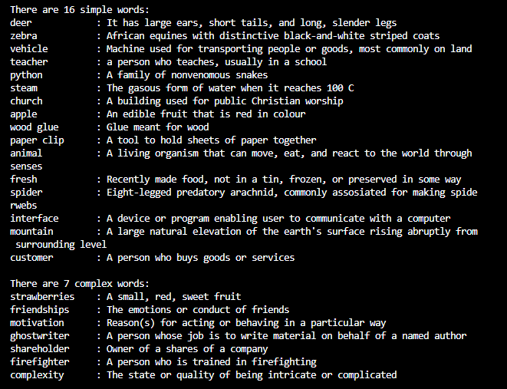

Figure Sample of printed word list

Note that simple words are words that are less than 10 characters long (excluding spaces) and complex words are words that are at least 10 characters long

## Add New Word

Enter ‘2’ at the word list editing menu begin adding a new word to the word list

Words for hangman may only include letters, spaces, and apostrophes ( ‘ ). All letters will be automatically converted to lowercase. If you try to enter a word that contains numbers or other special characters, the process of adding a word will be cancelled.

You should also ensure that the word you are adding is not already in the word list, as the script will not allow you to add an existing word.

After entering a valid word, you will be prompted to enter the meaning of the word. Please provide a useful description of the word as it may be used as a hint if the player uses a lifeline.

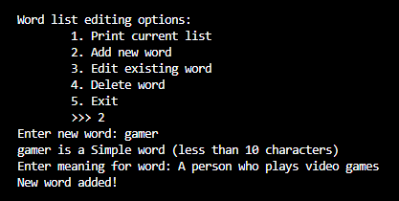

Figure A sample of adding a word and meaning to list

## Editing word

Enter ‘3’ at the word list editing menu to be prompted of the word you wish to edit (You can use the print word list function above to check which words needs to be edited).

After entering a word that is in the list, you would be prompted to enter ‘W’ or ‘M’ to edit the word spelling or meaning respectively. This input is not case sensitive, but entering any other value ends the word editing process.



Figure A sample of prompt to choose which data to edit

If you choose to edit the word spelling, ensure that the word you wish to change to does not contain numbers or special characters (outside of spaces and apostrophes), similar to the process of adding words.

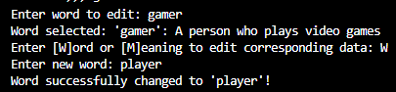

Figure Sample of successful word edit

If you choose to enter the word meaning, ensure that the new meaning is a meaningful description of the word, preferably the dictionary meaning.

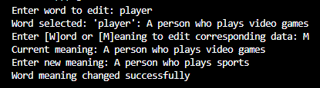

Figure A sample of a successful meaning edit

## Delete Word

Enter ‘4’ at the word list editing menu to be prompted of the word you wish to delete from the word list. If the word is in the word list, the word and its meaning will be printed, and you will be prompted to confirm the removal of the word. Enter ‘Y’ to confirm the removal, and any other values will cancel the process

Caution: This process is irreversible. Ensure you really intend to remove the word before confirming

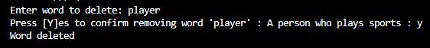

Figure A sample of successful delete from word list

## Create Empty List

Enter ‘5’ at the word list editing menu to be prompted to confirm the action. Confirm by entering ‘Y’, and an empty word list will be created, and the old list will be deleted.

Caution: This process is irreversible. Ensure you want to wipe the word list before confirming



Figure A sample of successful creation of empty list

# Edit Game Settings

Entering ‘2’ in the main menu shows the configurable game settings and their current value.

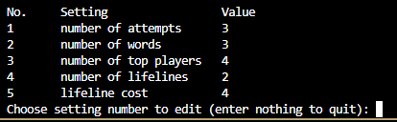

Figure List of configurable game settings

This table below lists what each setting value does

|  |  |  |  |
| --- | --- | --- | --- |
| **No** | **Setting name** | **Default value** | **Description** |
| 1 | Number of attempts | 3 | Number of games the player is allowed to play in one session |
| 2 | Number of words | 3 | Number of words (and therefore sets) the player must play per game |
| 3 | Number of top players | 4 | Number of top games (based on sets) shown |
| 4 | Number of lifelines | 2 | Number of times the lifeline feature can be used per game |
| 5 | Lifeline cost | 4 | The amount of points list for each use of the lifeline |

Enter a number between 1 to 5 to edit the corresponding setting value. You may also enter nothing (i.e pressing the enter key without entering any values) to quit the settings editing function.

After selecting a setting to edit, you will be asked to enter the new value. Ensure that you are entering a positive integer, as negative numbers and other characters will continuously prompt you to enter an acceptable number

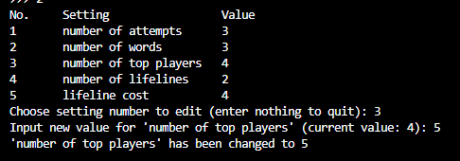

Figure Sample of successful settings edit

# Print Game Report

Enter ‘3’ in the main menu to be brought to prompts asking you to enter a start date and end date. The function will find games played between the stated dates (the function will search based on the time the game is started, not ended).

Please enter the dates in a DD/MM/YYYY format, or the function will detect an error and terminate itself. Do not shorten the year to two digits (2022 into 22), as the script cannot differentiate between long and short year forms.

You can also choose not to enter anything in the prompts to leave it as default dates instead. Default date is 1/1/1 for start date and the system date for end date.

The script will print out the following details from each game found in the date range:

* Player name
* Score
* Sets in game
* Lifelines used
* Complex words given
* Start date and time (DD/MM/YY, time in 24-hour format)
* End date and time

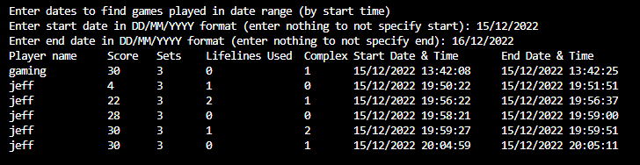

Figure Sample of printed game report

# Change password

Enter ‘4’ in the main menu to change the admin. For security reasons, the password is required to be secure against brute force attacks using these requirements:

* Length must be between 4 and 20 characters long
* Password must contain at least:
  + 1 uppercase letter
  + 1 lowercase letter
  + 1 number (0-9)
  + 1 valid special symbol (!@#$%)

If the password entered does not meet the requirements, or contains a invalid special character (spaces, &, etc), you will be repeatedly prompted to enter a valid password. To exit the change password function without changing the password, enter nothing (only press enter at the prompt).\

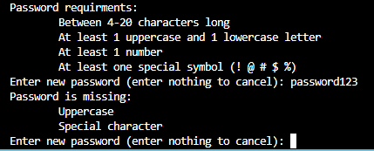

Figure Sample of an invalid password

Once a password that meets the requirements has been entered, you will be asked to re-enter the password. If both inputs are the same, the password will be updated for the next login onwards.

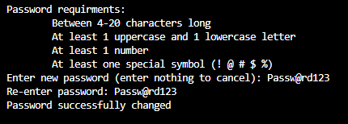

Figure Sample of a successful password change